SCBI- ForestGEO Recensus 2018
The SCBI plot is 25.6 ha (400 m x 640 m) divided in 640 quadrats of 20m x 20m. An estimate of 25 quadrats, or 1 ha should be completed per week (average 5 quadrats per day). The goal of the recensus is to revisit and measure all tagged stems, and to tag and map new recruitments over 1cm DBH.
METHODS
In the office:
- Select quadrats to cover during the day. Use the plot map to guide you.
- Check iPad batteries but make sure you PLUG iPads AT END OF WORKDAY
- If needed print datasheets per quadrat to cover during the day (located in V:\SIGEO\2-RECENSUS 2018\DATA\Forms to PRINT). Also print datasheets for new recruitment.
- Verify complete set of instruments:
  - DBH tapes (large and small)
  - Calipers
  - Compass
  - Five 30 m tapes.
  - 1.3 m poles.
  - Hammer, nails, wires (color wires for stems and wires for tags).
  - Metal tags already organized in carabineers for the respective columns.
  - Lumber crayons.
  - Orange flagging.

In the field:
We follow Condit (1998) protocols, which for a recensus can be summarized as follow:
- Navigate to selected quadrat. At SCBI, a blue re-bar located in the SW corner gives the quadrat names. For example, if the tags says 6-12 it indicates you are in column 6, row 12. It will be read as quadrat 612 in the database or field form.
- Locate the rebar and orientate yourself. Locate trees within quadrat. Coordinates (x, y) are given in reference to a 20x20m square.
- Set metric tapes around the quadrat perimeter. If the quadrat stem density is high, then install tapes across the 10m interval.
- Start surveying from the rebar working towards North, then East, South, and across to finish in next quadrat at north.

- MEASURING TREES: Good measures of stems are critical, be accurate! DBH must be measured perpendicular to the trunk. Locate a tree; use the 1.3 pole to make sure that the blue line is at 1.3 (or other POM). Measure DBH and record it. Use calipers for stems under 4cm DBH. Record DBH in centimeters (cm). If using calipers, use one decimal, don’t round up.

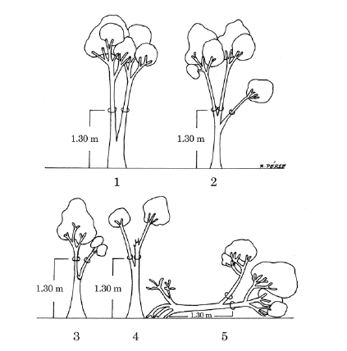
- MULTIPLE STEMS: If a tree is branching below 1.3 m and the branches are >1cm dbh, then the tree has multiple stems (Figure 1).

During the recensus 2013 color wires were attached to secondary stems up to 4 stems in each individual. The larger stem keeps the tag number.

- Use color code to for each secondary stem as indicated (only 5 stems should have wire):
- White – Second largest stem
- Blue – Third largest stem.
- Red – Fourth largest stem
- Green – Fifth largest stem
- Do not worry about the rest of the stems, but make an effort in the field to match stem size.
Figure 1. Multistem tree
- Re-census Spicebush: Multi-stem shrub with dead stems previously tagged.
  - If MAIN stem is dead, then move metal tag to next largest living stem and leave the colored wire for that stem. Write ‘M, main’ in Codes. Example: Main stem died, but Stem 2 is alive, then move metal tag to Stem 2 and leave or add white wire on Stem 2. In Codes write ‘M, main’ for Stem 2
    - If there are no living stems, then leave metal tag on original main stem. All stem gets a dead code (either DC, DS), no other codes.
  - If any secondary stems are dead, remove the colored wire and write ‘WR’ in Codes.
  - If colored wire is removed from a dead stem and there are living stems with no color wire, then continue in order with the existing color code system. Example: Stem 2 (white wire) is dead and wire is removed, Stem 3 is alive and has a blue wire, but Stem 4 is a new stem (no wire) then it is given a RED wire following the color code protocol, and then GREEN wire if there is a fifth stem.
  - If all the colors have been used, but there are less than 5 marked stems due to wire removal from dead stems, then restart the color wire protocol using two of the same color wire until there is a total of five living stems tagged; starting at the first live stem with no wire. Example: Spicebush in 2013 census had 4 stems alive (Main, white, blue, red), but in 2018 census Stems 2 and 4 are DS or DC and there are two new stems. First remove white and red wire from the dead stems, then use GREEN wire on Stem 5, and DOUBLE WHITE wire on Stem 6.
    - Double wires will follow the existing color progression (white, blue, red, green).
  - If main stem is DC or DT, and there are no living stems, remove the metal tag. Write ‘TR’ in codes to indicate the tag has been removed from the field.

- Use “Codes” if you need to give a stem condition, use the following:
A: alternate POM (point of measurement, different than 1.3m)
B: stem broken above 1.3 m,
C: dead above 1.3m
F: inside deer fence
G: ID to Genus certain
I: stem irregular where measured
J: Bent
L: leaning stem
M: multiple stems
main; main stem
P: prostrate stem (almost parallel to the ground)
S: secondary stem
TR: tag removed
WR: wire removed
X: stem broken below 1.3 m.

Note: memorize the stem codes like your SSN!

- DEAD STEM: A dead stems is measured if:
- Bark is complete and all the way around the stem.
- If bark is incomplete then enter 0 (zero) in DBH.
- Dead codes: DS = dead, stem standing, DC = dead, stem fallen, DT = dead, only tag found, DN = stem completely disintegrated, no stem at all or visible decay.

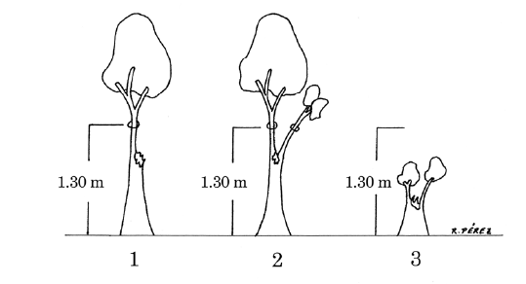
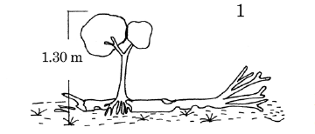
- RECRUITMENTS: Localize new plants (recruitment) above >1cm DBH, place a new tag, give x and y, measure DBH, and identify it. If identification is difficult attach flagging tape for later review. If the new plant has multiple stems, then proceed accordingly. Use the appropriate recruitment form.
- RESPROUT: If a plant broke its main stem since the prior census, but did not die, it is called a 'resprout'. The code 'R' is applied, plus the code ‘A’ indicating a change of POM. The new stem is measured at 1.3 m. If the new DBH is <1cm, the plant is given a DBH of 0. It remains part of the census and keeps its tag (Figure 2).
Figure 2. Resprout

- VINES: We won’t measure vines in 2018 but will register status (alive or dead) and the tree tag number on which the vine is climbing. Record tag number and status in the “Notes’ app if working with an IPad, if working in paper, then write same information (tag, status, landing tree) at the bottom of the data sheet. The data will then be transfer to a datasheet form kept in the lab (Erika) and to later be enter online.
Data quality control:
- Let’s all be stewards of the data although Erika will be in charge of the final data product.
- Every day, data should be transfer from tablets to computer. If paper is used in the field, data should be transcribed as soon as possible. See document “DATA ENTRY instructions_2018” for details (V:\SIGEO\2-RECENSUS 2018\DATA\Data entry)
- Species Id’s and DBH values should be broadly check for errors and should be checked continuously.
- Recheck of field measures will happen after 5% of trees have been measured (~2500 stems). Follow Condit et al. (1998) protocols for double-blind approach for random checks.

TIMELINE
The 3rd census at SCBI ForestGEO plot will take place from March 20 to September 30, 2018.
ACTIVITY | DATE
Recensus start | March 26, 2018
Census check for dbh errors | May 28, 2018 (or after 2 ha is completed, or 5% of trees (2400 stems), whatever come first)
Finish recensus (field measurements) | September 30th, 2018
Data review | From September 30th to October 30th, 2018
Final recensus report | December 15th, 2018

Although the protocols recommend finishing one column at a time, we plan to cover southeastern quadrats first, due to a higher stem density and difficult navigation during the growing months. See below a broad plan of measurements.

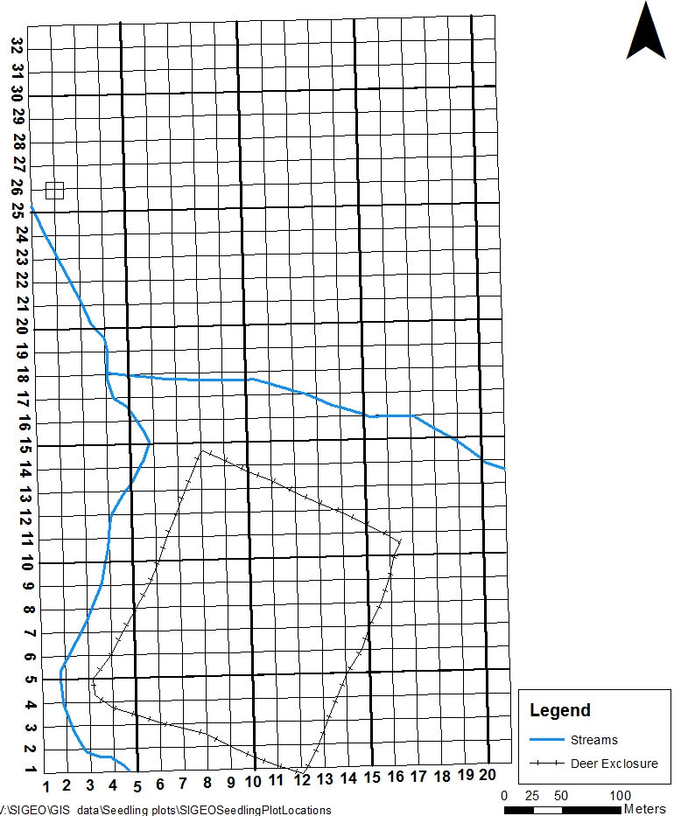

SEPTEMBER
Some quadrats have less than 20 stems, easy part!

March

JULY_AUGUST

Some quadrats have more 300 stems!

APRIL
MAY
JUNE

